DATA NETWORKS

تم هذا العمل بعون الله وإشراف الدكتور

DR. Ibaa Abdallah Oueichek

من الصف C13

محمد اديب بيطار Mhd_Adeeb_39127
Mohamed_amir_37174 محمد أمير دليواتي

1. Suggest an addressing plan that takes into consideration a future expansion of 200% in the number of employees of each department.
2. Give the subnet id of each department.
3. Give the broadcast address of each department.

1.2.3 Solutions:
Sales Department : | Subnet ID : 10.10.0.0/22
 | Broadcast : 10.10.2.255
HR Department: | Subnet ID : 10.20.0.0/22
 | Broadcast : 10.20.2.255
Technical Department | Subnet ID :10.30.0.0/21
 | Broadcast : 10.30.7.255
Administrator Department | Subnet ID : 10.40.0.0/22
 | Broadcast : 10.40.2.255

4.What are the two main advantages of splitting the main network into multiple VLANs?

A VLAN in a network is useful:

- Creating VLANs enables administrators to build broadcast domains with fewer users in each broadcast domain. This increases the bandwidth available to users because fewer users will contend for the bandwidth.
- It's better to create a subnet with limited IP range from class A than using the whole range of class A addresses to addressing just 200 ports.

5.What is the advantage of connecting each departmental switch using two links with the core switches C1 and C2?

In order to increase security in the event of interruption one of the links the switch move automatically to the second line of this linkage which is called the multiplier linking.

6. What are the switch port types of switches C1 and C2? What are the switch port types of the switch “sales”? What is the difference between the two types?

The c1 and c2 switch port mode is trunk , but the switch sales port mode is access.
Switch ports run in either access or trunk mode. In access mode, the interface belongs to one and only one VLAN. Normally a switch port in access mode attaches to an end user device or a server. The frames transmitted on an access link look like any other Ethernet frame.
Trunks, on the other hand, multiplex traffic for multiple VLANs over the same physical link. Trunk links usually interconnect switches.

7. What is the main challenge of connecting switches in this way?

When you using this way of connecting we have to know the MAC-address of each destination because we using SWITCHES.

8. Describe, briefly, a solution to overcome the above challenge?

We have to use routers instead of switches C1 & C2.

9. An IT consultant suggests dividing the network into MAC‐based VLANs instead of port--‐based.
a. Compare between the two types.

When in mac-based vlans , it depends on the mac address of your network adapter , for example if your network adapter(mac) related to the sales department so wherever you connect to the network , you will be connected as a device from sales department. While in port based vlans , it depends on the port you are connecting to.

1- Static VLAN membership:
- Assign certain port to a certain VLAN. ( port based VLAN )
- By default, all ports of the switch are assigned to VLAN .
2- Dynamic VLAN membership:
- Assign certain MAC to a certain VLAN. ( MAC based VLAN )
- Even if the PC changes its port on the switch , the PC still be connected to its VLAN.
- This is done by using VMPS ( VLAN membership policy server ).

b. Describe briefly the steps to set up MAC--‐based VLANs.
Sours wants to send packet to destination
Sours knows IP sours , IP destination
Sours needs to know are src & destination on same network
If no uses routing
If yes direct communication through L2 communication switching It need MAC address of destination therefore we need a function {IP to MAC} we have to use ARP protocol in Ethernet ARP is simple : src sends broadcast (who is owner of this IP) and destination will get it and answer.

10.Show the routing table of R1, supposing that we assign the last addressofEach subnet to the Router’s Interfaces.

Routing Table

Destination | Next Hop
Sales | 10.10.0.0
HR | 10.20.0.0
Technical | 10.30.0.0
Administrator | 10.40.0.0

When a computer sends a packet to a destination ,for example sales, the router will route this packet to the switch 10.10.0.0
The next hop Represents the subnet ID which the packet will be routed.

11. Do you need to add any other routes to make the connectivity possible between the four VLANs?Why?

No we don't need to add any other router because one router is enough to make the connection possible.

12. A PC from VLAN10 pings another PC in VLAN 20, and another PC between the switch “sales” and the central router is running a protocol analyzer.
a. Give the L2 source/destination addresses and L3 source/destination addresses for an outgoing ping packet.

In L2 the packet will be sent to the switch , the switch will read the header which contains the mac address of the destination, the switch will check the destination address in its switching table , and if the destinations is not in this table the switch will send the packet to router 1 (R1) , R1 will search in its routing table , if the destination is in it , then will sent it to R2 , so R2 will receive the packet and route it to LAN 2 when the destination is.

In L3 the packet will be sent to R1 directly , R2 will look at routing table to find out that the packet has to be routed to R2 and will send it to R2 , R2 will send it to its final destination.

b. Represent the protocol encapsulation for the ping packet as in TCP/IP model. You should determine the header length of each protocol

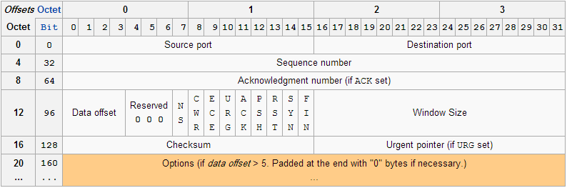

Source port (16 bits)
Destination port (16 bits)
Sequence number (32 bits)
Acknowledgment number (32 bits)
Data offset (4 bits)
Reserved (3 bits)
Flags (9 bits)
Window size (16 bits)
Checksum (16 bits)
Urgent pointer (16 bits)
Options (Variable 0–320 bits, divisible by 32)

13. Let LAN2 a network that is connected via R2 with R1 “central router”, as shown in Fig. 3.
a. Suggest a /30 subnet to the link between R1 and R2.

b. List the routes to be added on both routers to make the connectivity possible between LAN2 and the four VLANs in SCC Company

.

